Enter for your chance to WIN!

Two-week placement at the Marina Social in Dubai with
award winning Chef of the Year 2016 - Tristan Farmer
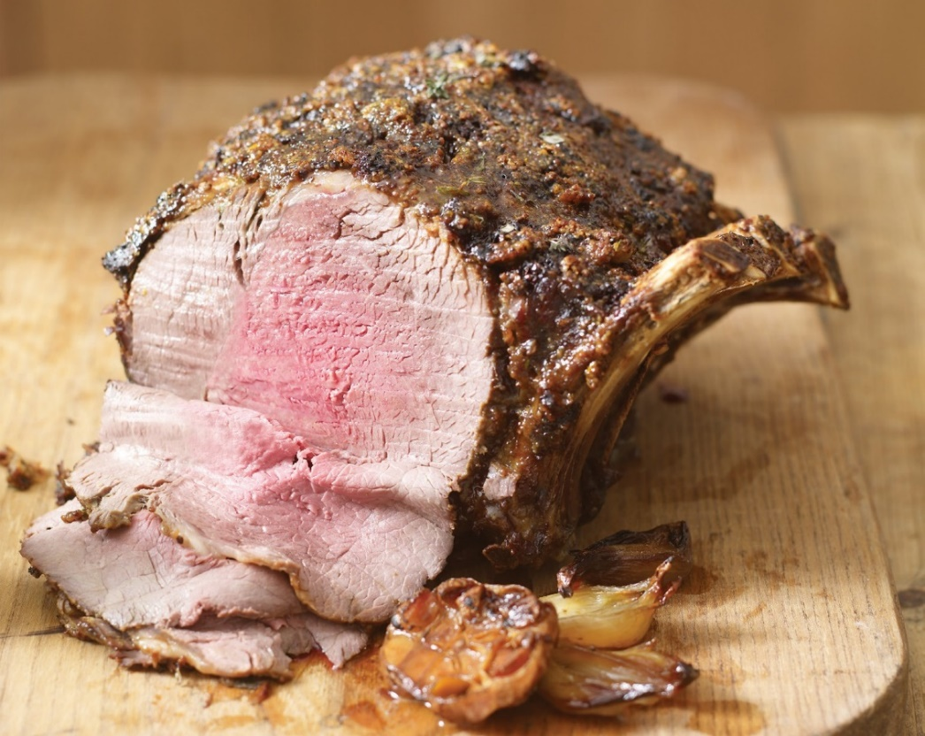

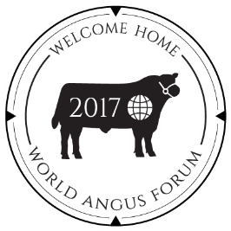

“Cook off” at Braehead Foods, Kilmarnock
Tuesday 16th May 2017

Entries close Friday 21st April 2017

www.worldangusforum2017.com
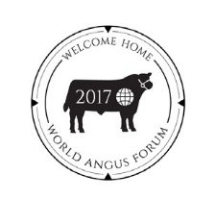
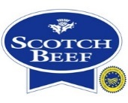

Thursday 15th June Monday 3rd July 2017

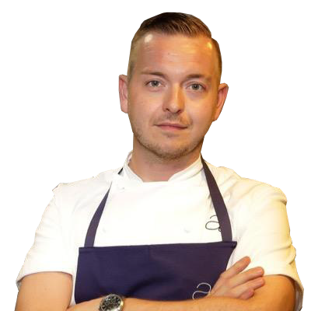

The Competition:
Aberdeen-Angus Cattle Society and World Angus Forum 2017 are searching for talented young Scottish chefs. The Chef competition is open to all budding young chefs, training in Scotland.

Aberdeen-Angus Scotch Beef PGI is the world’s finest beef breed with worldwide recognition of producing premium quality beef. The Aberdeen-Angus Cattle Society has a strong relationship with supermarkets, restaurants, farm shops and butchers alike, building the demand from consumers to a level where the beef can demand a premium.

At the Cook Off at Braehead Foods on Tuesday 16th May, entrants will be required to create a main course using Aberdeen-Angus Scotch Beef and 2 canapés from a mystery box with the main ingredient being Aberdeen-Angus Scotch Beef PGI.

The winning dish will showcase Aberdeen-Angus Scotch Beef PGI. The canapés will be served at the Gala Dinner on
Monday 26th June within the National Museum Scotland.

The Prizes:
There will be prizes for the top 3 competing students.
The overall winner will win a two-week placement at the Marina Social, situated in the Intercontinental Hotel, Dubai under the tuition of award winning Chef of the Year 2016, Tristin Farmer.

The 3 finalists will also be invited to the World Angus Forum 2017 on Monday 26th June 2017 at The Assembly Rooms, George Street, Edinburgh. The overall winner will be announced at the
conference. The two runners up will each win a week at a Scottish Michelin starred restaurant.

Chef Patron of Marina Social Dubai

Tristin Farmer

Thursday 15th June Monday 3rd July 2017

How to Enter:
Each entrant requires the backing of their lecturer or mentor to cement their application. Prior to entering the main competition, please feel free to host your own internal cook off and we will be happy to select the qualifying dish. An allocation of Aberdeen-Angus Scotch Beef PGI can be supplied for these cook offs.

We are looking for dishes that make the best use of Aberdeen-Angus Scotch Beef PGI with an original or imaginative twist. It is important that the flavour of the beef is enhanced by the recipe. An allocation of Aberdeen-Angus Scotch Beef PGI will be available to all entrants prior to the closing date to allow practice of the dishes. The dish must be presented, ready to be served.

A step-by-step guide, rules and compulsory ingredients are provided to help you with your entry application. The completed entry will include details of your recipe with all the ingredients.

The Judging:
Preliminary Round: Each student should submit written details on their dishes to Aberdeen-Angus Cattle Society office by Friday 21st April 2017 including ingredient list, detailed recipe and pictures. The ten best dishes will be chosen, and these short- listed students will be invited to participate in a ‘cook off’ final at Braehead Foods, Kilmarnock on Tuesday 16th May 2017.

Final: Each of the short-listed finalists will be asked to prepare, cook and present their dishes within a 3 hour ‘cook off’ at Braehead Foods, Kilmarnock on Tuesday 16th May 2017. The dishes will be judged by a panel of guest experts.

Thursday 15th June Monday 3rd July 2017

Entry Form

The Challenge

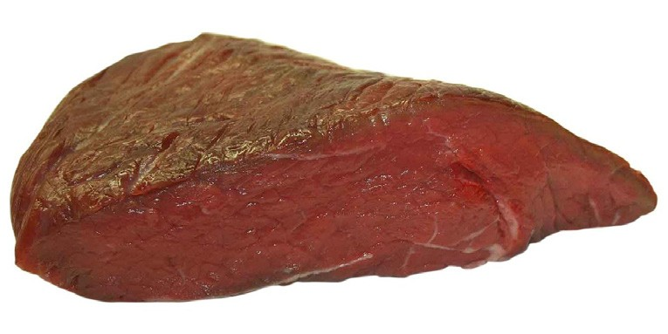
Create a main course dish using Aberdeen-Angus Scotch Beef PGI. The menu should make use of Scottish ingredients.

Create 2 x 2 canapés from a mystery box provided.
Main ingredient will be Aberdeen-Angus Scotch Beef PGI.

Entry Details
Name of Entrant:
Contact Telephone Number: Email address:

Mentor/Lecturer:
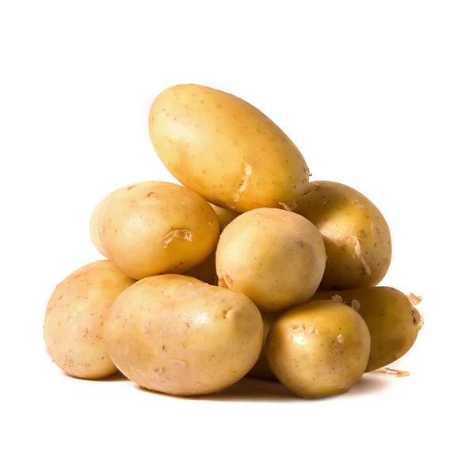
Training Partner: Contact Telephone Number: Email address:

Thursday 15th June Monday 3rd July 2017

Canapés – created from the mystery box provided on the day Name of Main Course: ………………………………………
Cost dish for 4 people: £…………………………
Please attach any relevant photographs or diagrams Ingredients (amounts and description):

Thursday 15th June Monday 3rd July 2017

The Closing Date:
The closing date for entries is Friday 21st April 2017, and the ‘cook off’ final will be held Tuesday 16th May 2017.

The finalists will be invited to the World Angus Forum 2017. For more information about the Forum visit: www.worldangusforum2017.com

For more information about the competition,
contact Hazel Baxter at Aberdeen-Angus Cattle Society
Tel: 01738 622477
M: 07938 247357
hazel@aberdeen-angus.co.uk

How to Enter:
Please send your completed entry form and menu (using the sheets provided) to:

Hazel M Baxter
World Angus Forum 2017 Co-ordinator Aberdeen-Angus Cattle Society Pedigree House
6 King’s Place Perth PH2 8AD
hazel@aberdeen-angus.co.uk
Thursday 15th June Monday 3rd July 2017

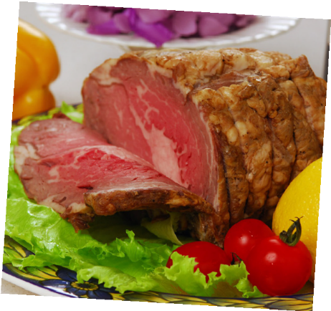
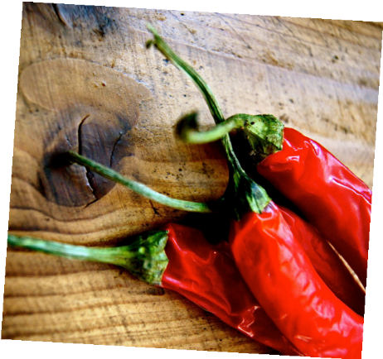
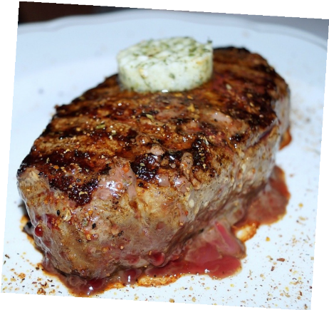
Competition Information
Tips and information for the ‘cook off’ finalists:

- Practise your menu as much as possible.

- Hygiene is also an important part of the competition. You are required to work cleanly and tidily with regard to hygiene and food safety.

- The Aberdeen-Angus Cattle Society will provide the ingredients for the “cook off”. Each student will be
responsible for supplying the society with a list of their food ingredient requirements by Friday 5th May.

- Advanced preparation of ingredients is not allowed.
The only items that competitors can bring with them to the ‘cook off’ are fresh stocks, puff pastry, filo pastry,
demi-glace or basic brown sauce.

- The Aberdeen-Angus Cattle Society will provide the ingredients for the mystery box

- All equipment including serving plates and tablecloths is to be supplied by the student.

- A produce station will be available at Braehead Cook School.

- All finalists are allowed to bring two people with them if they wish. (These names should be sent to the Society by Friday 5th May 2017).

Thursday 15th June Monday 3rd July 2017

Terms and Conditions:

- Entrants must be training to be a chef and based in Scotland.

- The short-listed finalists will be contacted by Friday 5th May 2017.

- Entrants must be available to attend the ‘cook-off’ in Braehead Food demonstration kitchen on Tuesday 16th May 2017.

- The successful finalists must be available for Monday 26th June at the Assembly Rooms, George Street, Edinburgh and the National Museum Scotland.

- The finalists will be judged by an expert panel.

- The voting panel’s decision is final. No correspondence on the decision will be entered into.
Kitchen protocol:

Each student will be asked to prepare, cook and present their dish and canapés within a 3 hour period (11.00am – 2.00 pm) at Braehead Foods Demonstration Kitchen, Kilmarnock. An additional ½ hour will be allowed at the start of the event (10.30 – 11.00 am) for unpacking and setting up the finalist’s workstations. For the ‘cook off’:

- Long hair must be tied back - contestants may be asked to wear a hairnet during food preparation

- Contestants must wear clean, low heeled shoes that cover the feet, preferably with a non-slip sole

- No nail varnish to be worn

- Jewellery must be kept to a minimum

- All food will be ordered in advance and provided by Aberdeen-Angus Cattle Society.
- Drinking water will be provided during session

- Contestants should draw up a rough ‘work plan’ to utilise their time to best advantage, and help focus at the event

- All contestants should advise the organisers of any food allergies or special dietary requirements before the event

- Each student can bring 2 specialised pieces of equipment on the day.

- All contestants should advise the organisers if they have had any food poisoning symptoms prior to the cook-off (anyone with food poisoning symptoms must not handle food for at least 48hrs after the cessation of symptoms)

‘Cook Off’ rules and regulations:

The ‘cook off’ will start with a short talk by a representative from Braehead Foods to advise competitors on:

•Kitchen familiarization: (operation of cookers, use of coloured boards, location of fridges, freezer, hand wash sinks, First Aid, Fire Exits, toilets)

•Kitchen safety - Risk assessment and demonstration, if necessary, of kitchen equipment, safe knife handling, oven gloves, spills, etc

•Kitchen hygiene - Contestants MUST wash their hands at the hand wash sink using hot water antibacteriacidal soap and nailbrush. Paper towels are provided

•Hands must be washed:

- On entering and re-entering the kitchen
- After going to the toilet
- After touching raw foods
- After touching face, nose or mouth
- After eating, coughing sneezing or blowing nose

